CSS ASSIGNMENT

1. Write the CSS file for the following HTML page?

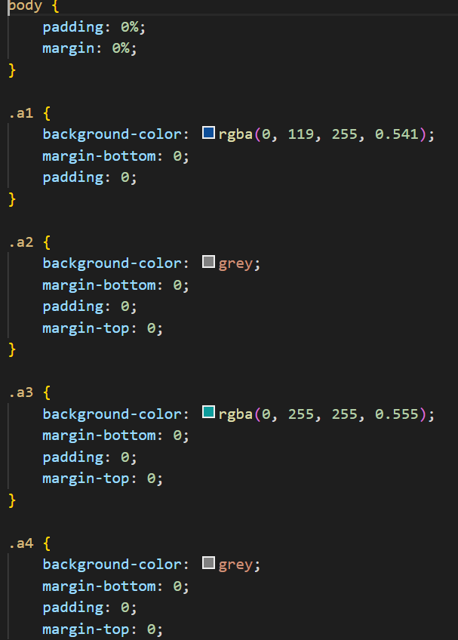

Output:

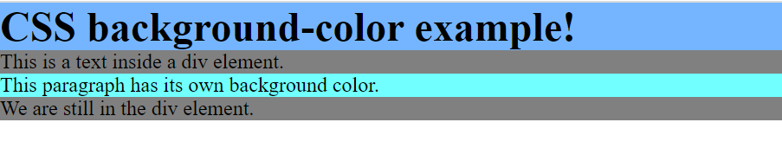

1. Write the CSS file for the following HTML page?

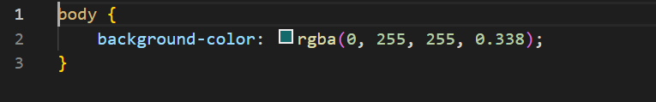

Output:

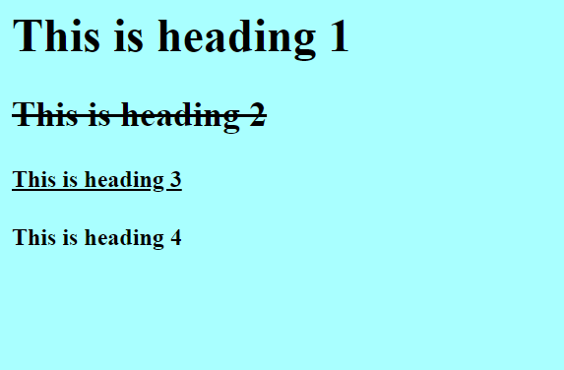

1. Write the CSS file for the following HTML page to display the text?

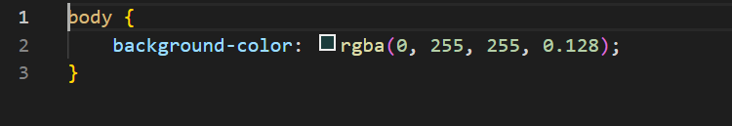

Output:

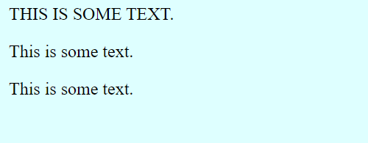

1. Write the CSS file for the following HTML page to add different colours to visit/unvisited links.

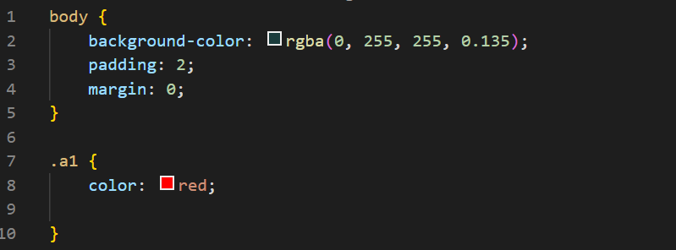

Output:



1. Write the CSS file for the following HTML page?

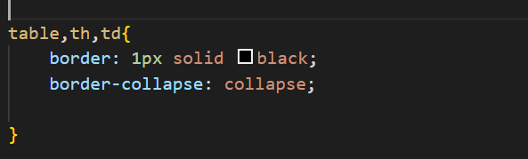

Output:

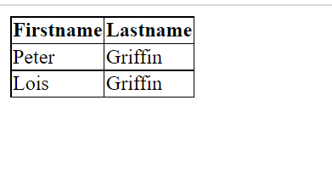

1. Write the CSS file for the following HTML page?

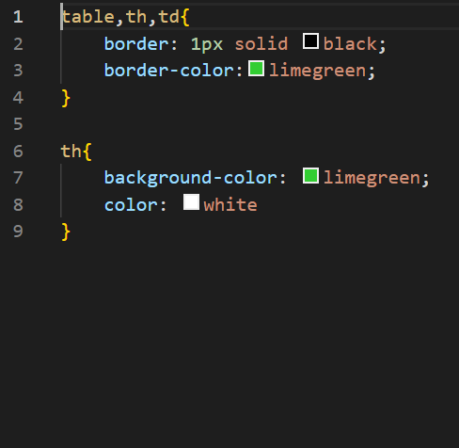

Output:

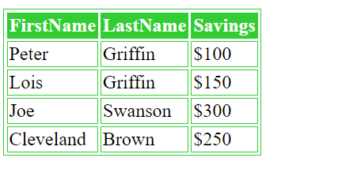

1. Write the CSS file for the following HTML page to set the colour outline.

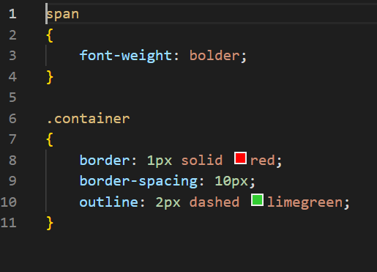

Output:



1. Write the CSS file for the following HTML page to set the border width of the page.

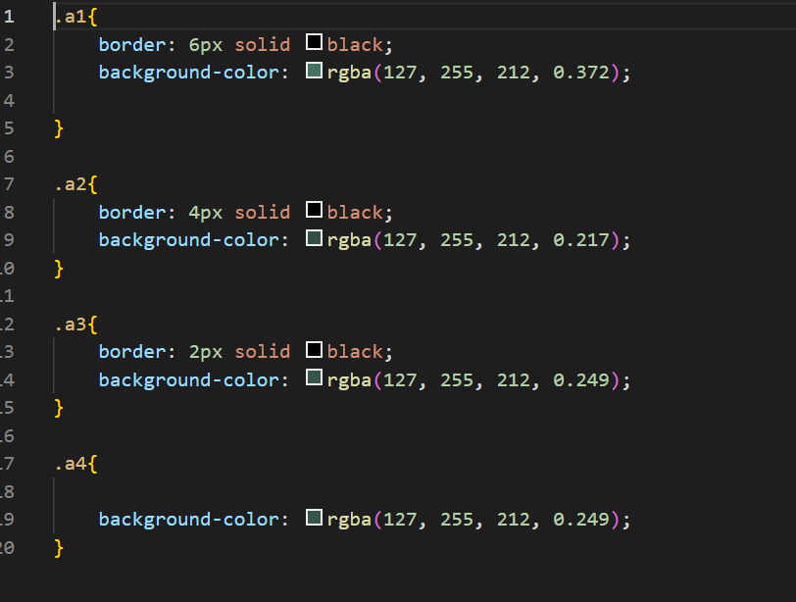

Output:

